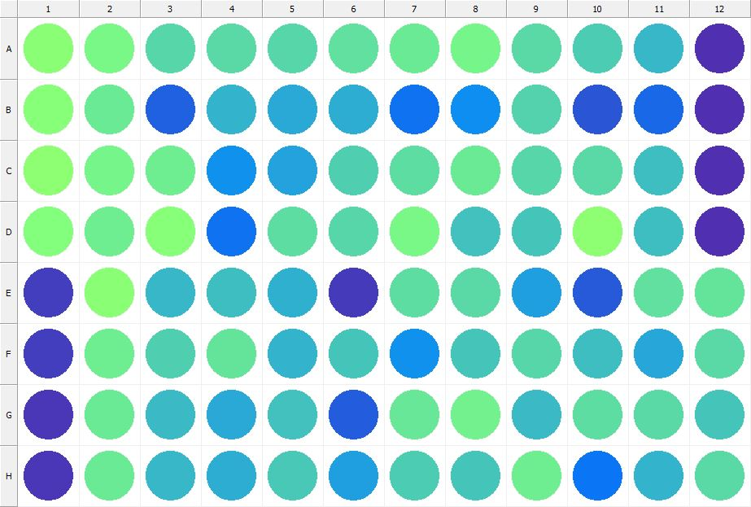

|  |
| --- |
| **Results for Tim_CTB(1) - channel 1 (RFU)** |

|  |  |  |  |  |  |  |  |  |  |  |  |  |
| --- | --- | --- | --- | --- | --- | --- | --- | --- | --- | --- | --- | --- |
|  | 01 | 02 | 03 | 04 | 05 | 06 | 07 | 08 | 09 | 10 | 11 | 12 |
| A | 177697 | 166554 | 143973 | 146633 | 142858 | 151322 | 157839 | 165785 | 146648 | 137361 | 123914 | 32278 |
| B | 176252 | 157435 | 65263 | 120029 | 112603 | 115879 | 75989 | 96006 | 141588 | 57533 | 70211 | 31409 |
| C | 179864 | 164247 | 160645 | 97139 | 109213 | 139843 | 148726 | 156995 | 144565 | 145750 | 127719 | 33106 |
| D | 174214 | 161162 | 177018 | 77464 | 148001 | 143886 | 167506 | 130601 | 133205 | 181702 | 127269 | 33551 |
| E | 41363 | 179388 | 122824 | 127981 | 119123 | 39787 | 148725 | 146502 | 106960 | 60111 | 150177 | 152098 |
| F | 40621 | 160639 | 139710 | 152845 | 120753 | 131123 | 97316 | 132648 | 142739 | 127172 | 110326 | 145357 |
| G | 36583 | 157009 | 124991 | 113616 | 129879 | 62118 | 156024 | 163251 | 124211 | 147451 | 145431 | 132429 |
| H | 37474 | 157062 | 123166 | 114917 | 135510 | 106816 | 136094 | 132237 | 159328 | 79240 | 119755 | 146647 |

|  |  |
| --- | --- |
| **Plate information** | |
|  | |
| **Plate** | 1 |
| **Repeat** | 1 |
| **Barcode** |  |
| **Measured height** | 14.78 |
| **Inside temperature at start** | 23.64 |
| **Inside temperature at end** | 23.64 |
| **Humidity at start** | 15.5 |
| **Humidity at end** | 15.9 |
| **Ambient temperature at start** | 23.34 |
| **Ambient temperature at end** | 23.44 |
| **Group** | 1 |
| **Label** | Tim_CTB(1) |
| **ScanX** | 0 |
| **ScanY** | 0 |
| **Measinfo** | De=1st Ex=Top Em=Top Wdw=N/A (14) |
| **Kinetics** | 0 |
| **Measurement date** | 11/21/2022 2:45:21 PM |
|  | |

|  |
| --- |
| **Background information** |
| Legend:  HDR1 - Plate  HDR2 - Label  HDR3 - Result  HDR4 - Signal  HDR5 - Flashes/Time  HDR6 - Meastime  HDR7 - MeasInfo |
| HDR1 HDR2 HDR3 HDR4 HDR5 HDR6 HDR7  1 Tim_CTB 0 1232 1 00:00:00.000 De=1st Ex=Top Em=Top Wdw=N/A (14) |
|  |

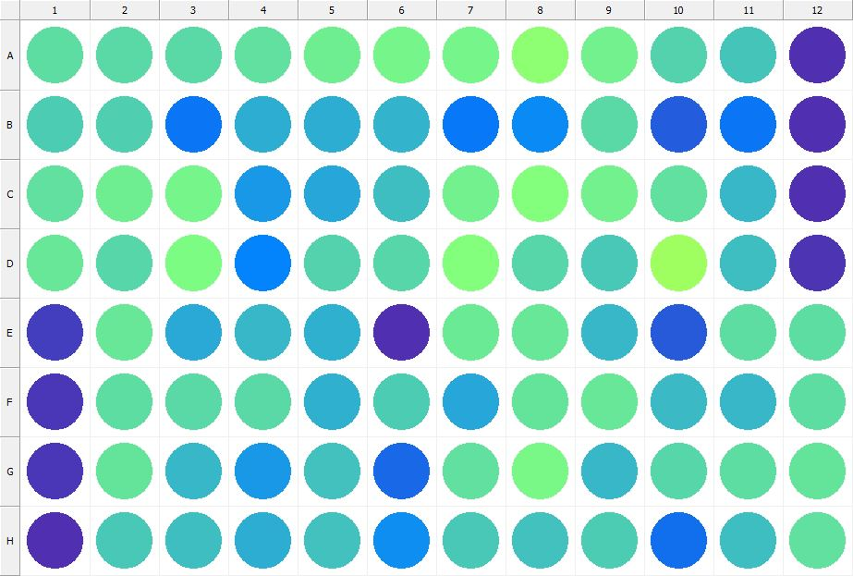

|  |
| --- |
| **Results for Tim_CTB(1) - channel 1 (RFU)** |

|  |  |  |  |  |  |  |  |  |  |  |  |  |
| --- | --- | --- | --- | --- | --- | --- | --- | --- | --- | --- | --- | --- |
|  | 01 | 02 | 03 | 04 | 05 | 06 | 07 | 08 | 09 | 10 | 11 | 12 |
| A | 147649 | 145036 | 146797 | 149785 | 159741 | 164264 | 164040 | 180585 | 162594 | 142620 | 132871 | 33398 |
| B | 135918 | 139139 | 79822 | 116191 | 116919 | 120070 | 80933 | 92341 | 146839 | 62085 | 78375 | 33173 |
| C | 150622 | 160518 | 165550 | 103095 | 112345 | 128486 | 162033 | 174230 | 161670 | 151032 | 122634 | 33396 |
| D | 155500 | 144085 | 170218 | 88859 | 142532 | 142927 | 172999 | 144346 | 134063 | 193237 | 127543 | 33803 |
| E | 41701 | 155268 | 114400 | 123984 | 118954 | 31365 | 157860 | 154602 | 123356 | 60877 | 149182 | 147970 |
| F | 36474 | 147893 | 147134 | 146024 | 118887 | 135754 | 110476 | 153004 | 155988 | 125929 | 123053 | 147673 |
| G | 36476 | 153763 | 122779 | 101631 | 130261 | 68656 | 150292 | 166904 | 123247 | 144160 | 149543 | 153697 |
| H | 32331 | 134117 | 126901 | 115083 | 129875 | 95959 | 133828 | 129903 | 137030 | 75202 | 126426 | 151215 |

|  |  |
| --- | --- |
| **Plate information** | |
|  | |
| **Plate** | 2 |
| **Repeat** | 1 |
| **Barcode** |  |
| **Measured height** | 14.78 |
| **Inside temperature at start** | 23.64 |
| **Inside temperature at end** | 23.66 |
| **Humidity at start** | 16 |
| **Humidity at end** | 15.9 |
| **Ambient temperature at start** | 23.44 |
| **Ambient temperature at end** | 23.56 |
| **Group** | 1 |
| **Label** | Tim_CTB(1) |
| **ScanX** | 0 |
| **ScanY** | 0 |
| **Measinfo** | De=1st Ex=Top Em=Top Wdw=N/A (14) |
| **Kinetics** | 0 |
| **Measurement date** | 11/21/2022 2:46:03 PM |
|  | |

|  |
| --- |
| **Background information** |
| Legend:  HDR1 - Plate  HDR2 - Label  HDR3 - Result  HDR4 - Signal  HDR5 - Flashes/Time  HDR6 - Meastime  HDR7 - MeasInfo |
| HDR1 HDR2 HDR3 HDR4 HDR5 HDR6 HDR7  2 Tim_CTB 0 1114 1 00:00:00.000 De=1st Ex=Top Em=Top Wdw=N/A (14) |
|  |

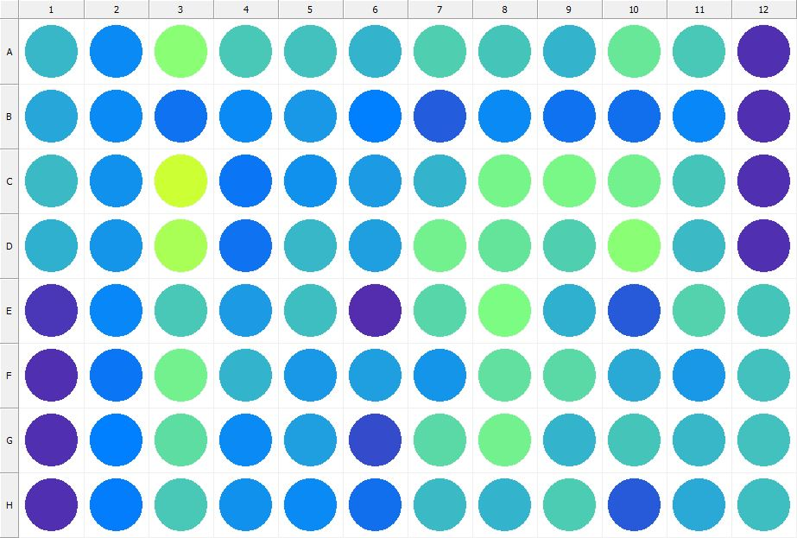

|  |
| --- |
| **Results for Tim_CTB(1) - channel 1 (RFU)** |

|  |  |  |  |  |  |  |  |  |  |  |  |  |
| --- | --- | --- | --- | --- | --- | --- | --- | --- | --- | --- | --- | --- |
|  | 01 | 02 | 03 | 04 | 05 | 06 | 07 | 08 | 09 | 10 | 11 | 12 |
| A | 123728 | 93396 | 178983 | 133872 | 128986 | 121165 | 138279 | 131255 | 121019 | 156170 | 134668 | 32789 |
| B | 111781 | 93462 | 76621 | 93390 | 101536 | 85145 | 62144 | 93578 | 76058 | 73574 | 90766 | 32799 |
| C | 126217 | 96937 | 222704 | 79562 | 98229 | 103508 | 121038 | 165676 | 166645 | 162042 | 133286 | 33210 |
| D | 117160 | 99608 | 199623 | 76632 | 122775 | 106082 | 163487 | 153278 | 138776 | 179706 | 125195 | 33252 |
| E | 37615 | 89928 | 133776 | 103599 | 126898 | 30447 | 142656 | 169756 | 118390 | 60179 | 140658 | 132629 |
| F | 33479 | 78804 | 163212 | 120791 | 103167 | 106363 | 100663 | 150505 | 145613 | 113311 | 102858 | 129869 |
| G | 32976 | 85850 | 149569 | 93607 | 106003 | 51888 | 145576 | 161944 | 120475 | 132873 | 122587 | 130370 |
| H | 31754 | 82528 | 135483 | 98043 | 92970 | 74291 | 125286 | 120758 | 137138 | 60667 | 113140 | 128718 |

|  |  |
| --- | --- |
| **Plate information** | |
|  | |
| **Plate** | 3 |
| **Repeat** | 1 |
| **Barcode** |  |
| **Measured height** | 14.78 |
| **Inside temperature at start** | 23.64 |
| **Inside temperature at end** | 23.64 |
| **Humidity at start** | 15.5 |
| **Humidity at end** | 15.5 |
| **Ambient temperature at start** | 23.34 |
| **Ambient temperature at end** | 23.34 |
| **Group** | 1 |
| **Label** | Tim_CTB(1) |
| **ScanX** | 0 |
| **ScanY** | 0 |
| **Measinfo** | De=1st Ex=Top Em=Top Wdw=N/A (14) |
| **Kinetics** | 0 |
| **Measurement date** | 11/21/2022 2:46:43 PM |
|  | |

|  |
| --- |
| **Background information** |
| Legend:  HDR1 - Plate  HDR2 - Label  HDR3 - Result  HDR4 - Signal  HDR5 - Flashes/Time  HDR6 - Meastime  HDR7 - MeasInfo |
| HDR1 HDR2 HDR3 HDR4 HDR5 HDR6 HDR7  3 Tim_CTB 0 1082 1 00:00:00.000 De=1st Ex=Top Em=Top Wdw=N/A (14) |
|  |

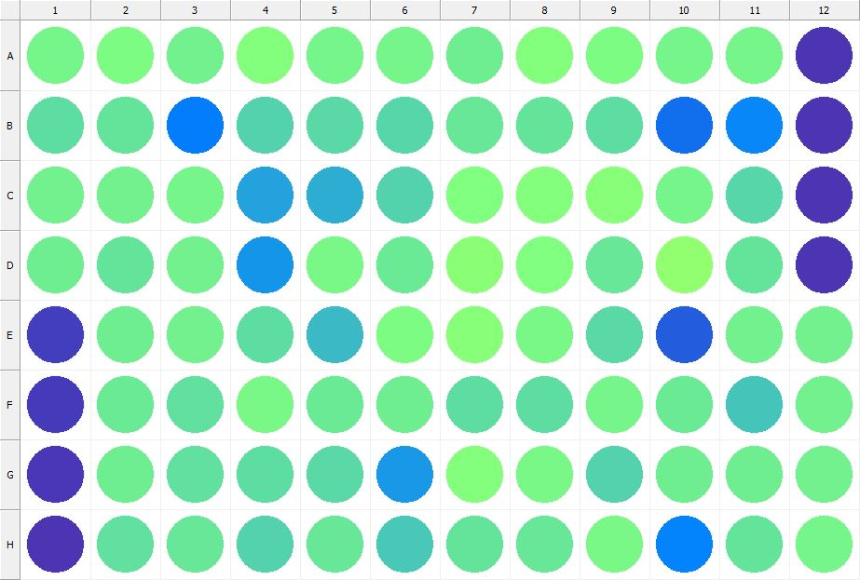

|  |
| --- |
| **Results for Tim_CTB(1) - channel 1 (RFU)** |

|  |  |  |  |  |  |  |  |  |  |  |  |  |
| --- | --- | --- | --- | --- | --- | --- | --- | --- | --- | --- | --- | --- |
|  | 01 | 02 | 03 | 04 | 05 | 06 | 07 | 08 | 09 | 10 | 11 | 12 |
| A | 164661 | 169820 | 161478 | 174839 | 165223 | 164855 | 159634 | 174449 | 169634 | 164780 | 163906 | 34848 |
| B | 147874 | 152670 | 83153 | 141958 | 145877 | 144270 | 156035 | 152876 | 147428 | 74189 | 90708 | 34288 |
| C | 161338 | 163323 | 164088 | 109725 | 115237 | 142077 | 171217 | 174716 | 175634 | 165799 | 143148 | 33672 |
| D | 160720 | 152859 | 162843 | 99534 | 166625 | 158053 | 179177 | 172460 | 154746 | 182825 | 152933 | 35510 |
| E | 41314 | 160594 | 161210 | 148524 | 125573 | 169458 | 175703 | 166664 | 146314 | 62940 | 163443 | 162443 |
| F | 38635 | 156578 | 151787 | 166986 | 158494 | 159696 | 147567 | 147644 | 165247 | 157818 | 132763 | 162876 |
| G | 37656 | 158980 | 151558 | 149352 | 145324 | 102674 | 173377 | 166802 | 141817 | 161019 | 159509 | 161276 |
| H | 33842 | 150266 | 154437 | 141635 | 156414 | 133604 | 153270 | 156008 | 167750 | 87920 | 152758 | 164270 |

|  |  |
| --- | --- |
| **Plate information** | |
|  | |
| **Plate** | 4 |
| **Repeat** | 1 |
| **Barcode** |  |
| **Measured height** | 14.78 |
| **Inside temperature at start** | 23.64 |
| **Inside temperature at end** | 23.66 |
| **Humidity at start** | 15.4 |
| **Humidity at end** | 15.4 |
| **Ambient temperature at start** | 23.15 |
| **Ambient temperature at end** | 23.17 |
| **Group** | 1 |
| **Label** | Tim_CTB(1) |
| **ScanX** | 0 |
| **ScanY** | 0 |
| **Measinfo** | De=1st Ex=Top Em=Top Wdw=N/A (14) |
| **Kinetics** | 0 |
| **Measurement date** | 11/21/2022 2:47:38 PM |
|  | |

|  |
| --- |
| **Background information** |
| Legend:  HDR1 - Plate  HDR2 - Label  HDR3 - Result  HDR4 - Signal  HDR5 - Flashes/Time  HDR6 - Meastime  HDR7 - MeasInfo |
| HDR1 HDR2 HDR3 HDR4 HDR5 HDR6 HDR7  4 Tim_CTB 0 1108 1 00:00:00.000 De=1st Ex=Top Em=Top Wdw=N/A (14) |
|  |

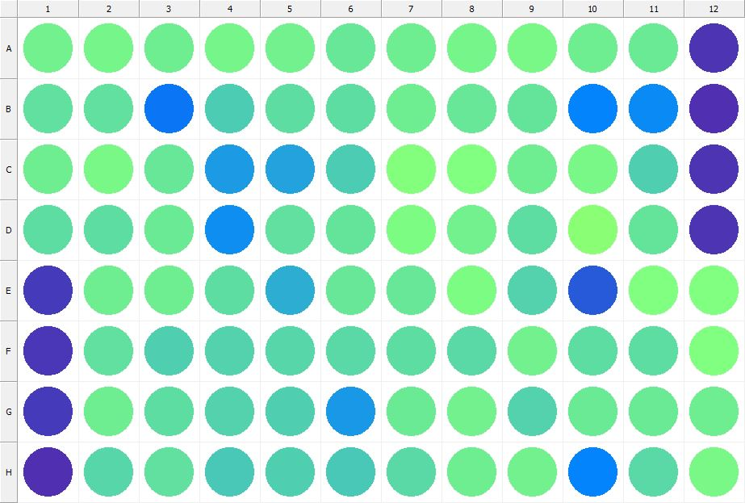

|  |
| --- |
| **Results for Tim_CTB(1) - channel 1 (RFU)** |

|  |  |  |  |  |  |  |  |  |  |  |  |  |
| --- | --- | --- | --- | --- | --- | --- | --- | --- | --- | --- | --- | --- |
|  | 01 | 02 | 03 | 04 | 05 | 06 | 07 | 08 | 09 | 10 | 11 | 12 |
| A | 161287 | 163818 | 160667 | 164161 | 161371 | 155981 | 160661 | 165331 | 166072 | 159870 | 157341 | 34282 |
| B | 150701 | 150242 | 78163 | 136330 | 147914 | 147488 | 160142 | 156540 | 152584 | 87014 | 93500 | 33358 |
| C | 159692 | 165860 | 154325 | 103475 | 108740 | 135878 | 173099 | 171346 | 160810 | 166894 | 139955 | 35739 |
| D | 149236 | 147629 | 158808 | 96199 | 150695 | 153964 | 168901 | 161380 | 149595 | 177623 | 153543 | 35203 |
| E | 39797 | 160172 | 160210 | 148263 | 116776 | 154387 | 156025 | 169351 | 142543 | 61069 | 171093 | 171722 |
| F | 36347 | 151579 | 139560 | 142278 | 144235 | 145755 | 149201 | 146179 | 161981 | 148602 | 148216 | 171117 |
| G | 39609 | 160166 | 149372 | 141026 | 138909 | 102337 | 156844 | 161909 | 142336 | 156900 | 158353 | 160264 |
| H | 33212 | 144653 | 151097 | 135538 | 140239 | 134598 | 145455 | 159654 | 162453 | 87508 | 145043 | 166150 |

|  |  |
| --- | --- |
| **Plate information** | |
|  | |
| **Plate** | 5 |
| **Repeat** | 1 |
| **Barcode** |  |
| **Measured height** | 14.78 |
| **Inside temperature at start** | 23.64 |
| **Inside temperature at end** | 23.64 |
| **Humidity at start** | 15.9 |
| **Humidity at end** | 15.5 |
| **Ambient temperature at start** | 23.25 |
| **Ambient temperature at end** | 23.25 |
| **Group** | 1 |
| **Label** | Tim_CTB(1) |
| **ScanX** | 0 |
| **ScanY** | 0 |
| **Measinfo** | De=1st Ex=Top Em=Top Wdw=N/A (14) |
| **Kinetics** | 0 |
| **Measurement date** | 11/21/2022 2:48:26 PM |
|  | |

|  |
| --- |
| **Background information** |
| Legend:  HDR1 - Plate  HDR2 - Label  HDR3 - Result  HDR4 - Signal  HDR5 - Flashes/Time  HDR6 - Meastime  HDR7 - MeasInfo |
| HDR1 HDR2 HDR3 HDR4 HDR5 HDR6 HDR7  5 Tim_CTB 0 1048 1 00:00:00.000 De=1st Ex=Top Em=Top Wdw=N/A (14) |
|  |

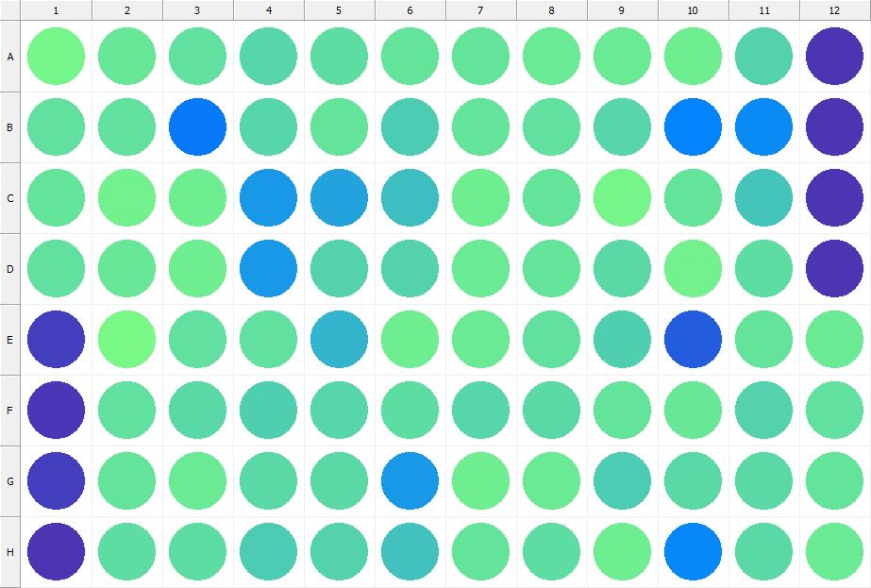

|  |
| --- |
| **Results for Tim_CTB(1) - channel 1 (RFU)** |

|  |  |  |  |  |  |  |  |  |  |  |  |  |
| --- | --- | --- | --- | --- | --- | --- | --- | --- | --- | --- | --- | --- |
|  | 01 | 02 | 03 | 04 | 05 | 06 | 07 | 08 | 09 | 10 | 11 | 12 |
| A | 164483 | 155270 | 151794 | 144066 | 148911 | 152960 | 153949 | 158106 | 158126 | 160346 | 142227 | 35269 |
| B | 150602 | 151615 | 80342 | 143599 | 153953 | 136067 | 154144 | 150507 | 144413 | 88040 | 92092 | 34170 |
| C | 153255 | 162472 | 159637 | 103147 | 109760 | 127368 | 159872 | 153826 | 163916 | 153820 | 131994 | 34355 |
| D | 151843 | 156375 | 159291 | 102025 | 141494 | 141556 | 157366 | 154078 | 145587 | 163222 | 147786 | 35917 |
| E | 40833 | 166070 | 151525 | 151744 | 120320 | 160067 | 157223 | 150151 | 138786 | 63305 | 153275 | 158753 |
| F | 36686 | 151926 | 146144 | 139029 | 144803 | 148191 | 144240 | 145597 | 154053 | 154929 | 141289 | 151092 |
| G | 41482 | 153266 | 157337 | 145813 | 145427 | 102845 | 159002 | 158036 | 137157 | 145202 | 146635 | 153319 |
| H | 34026 | 148175 | 148573 | 136403 | 142174 | 129664 | 151970 | 149185 | 159492 | 89795 | 146835 | 158446 |

|  |  |
| --- | --- |
| **Plate information** | |
|  | |
| **Plate** | 6 |
| **Repeat** | 1 |
| **Barcode** |  |
| **Measured height** | 14.78 |
| **Inside temperature at start** | 23.64 |
| **Inside temperature at end** | 23.64 |
| **Humidity at start** | 15.5 |
| **Humidity at end** | 15.9 |
| **Ambient temperature at start** | 23.25 |
| **Ambient temperature at end** | 23.25 |
| **Group** | 1 |
| **Label** | Tim_CTB(1) |
| **ScanX** | 0 |
| **ScanY** | 0 |
| **Measinfo** | De=1st Ex=Top Em=Top Wdw=N/A (14) |
| **Kinetics** | 0 |
| **Measurement date** | 11/21/2022 2:49:08 PM |
|  | |

|  |
| --- |
| **Background information** |
| Legend:  HDR1 - Plate  HDR2 - Label  HDR3 - Result  HDR4 - Signal  HDR5 - Flashes/Time  HDR6 - Meastime  HDR7 - MeasInfo |
| HDR1 HDR2 HDR3 HDR4 HDR5 HDR6 HDR7  6 Tim_CTB 0 1039 1 00:00:00.000 De=1st Ex=Top Em=Top Wdw=N/A (14) |
|  |

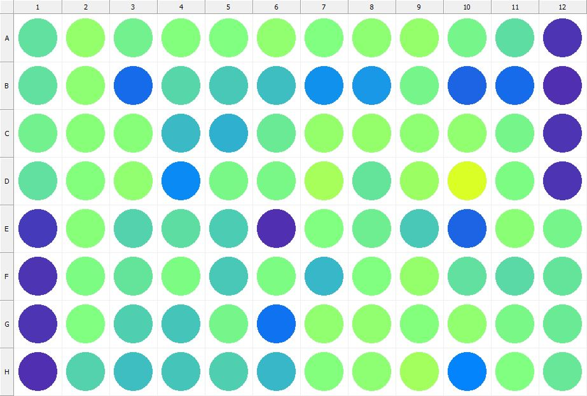

|  |
| --- |
| **Results for Tim_CTB(1) - channel 1 (RFU)** |

|  |  |  |  |  |  |  |  |  |  |  |  |  |
| --- | --- | --- | --- | --- | --- | --- | --- | --- | --- | --- | --- | --- |
|  | 01 | 02 | 03 | 04 | 05 | 06 | 07 | 08 | 09 | 10 | 11 | 12 |
| A | 150990 | 184959 | 162417 | 173869 | 171250 | 183437 | 171419 | 181614 | 185724 | 164090 | 148802 | 34394 |
| B | 150301 | 180236 | 72577 | 143830 | 135482 | 128306 | 98285 | 102175 | 163726 | 67089 | 70868 | 33319 |
| C | 161979 | 175305 | 175705 | 125810 | 117813 | 156951 | 186020 | 184722 | 179878 | 183869 | 164184 | 34455 |
| D | 150577 | 173902 | 182779 | 92006 | 168149 | 166258 | 196298 | 153341 | 189844 | 231150 | 168203 | 35429 |
| E | 38435 | 176552 | 140828 | 148716 | 137077 | 31799 | 170694 | 159612 | 134501 | 67541 | 178002 | 164832 |
| F | 34730 | 169030 | 153418 | 168819 | 135162 | 168258 | 122823 | 171160 | 184734 | 151845 | 145560 | 153584 |
| G | 34788 | 172217 | 139522 | 133296 | 163886 | 76548 | 182903 | 182804 | 174716 | 182929 | 166435 | 157822 |
| H | 32816 | 142208 | 128009 | 131990 | 138548 | 122177 | 173258 | 180057 | 193997 | 88497 | 171193 | 155234 |

|  |  |
| --- | --- |
| **Plate information** | |
|  | |
| **Plate** | 7 |
| **Repeat** | 1 |
| **Barcode** |  |
| **Measured height** | 14.78 |
| **Inside temperature at start** | 23.64 |
| **Inside temperature at end** | 23.64 |
| **Humidity at start** | 15.5 |
| **Humidity at end** | 15.5 |
| **Ambient temperature at start** | 23.34 |
| **Ambient temperature at end** | 23.34 |
| **Group** | 1 |
| **Label** | Tim_CTB(1) |
| **ScanX** | 0 |
| **ScanY** | 0 |
| **Measinfo** | De=1st Ex=Top Em=Top Wdw=N/A (14) |
| **Kinetics** | 0 |
| **Measurement date** | 11/21/2022 2:49:48 PM |
|  | |

|  |
| --- |
| **Background information** |
| Legend:  HDR1 - Plate  HDR2 - Label  HDR3 - Result  HDR4 - Signal  HDR5 - Flashes/Time  HDR6 - Meastime  HDR7 - MeasInfo |
| HDR1 HDR2 HDR3 HDR4 HDR5 HDR6 HDR7  7 Tim_CTB 0 1023 1 00:00:00.000 De=1st Ex=Top Em=Top Wdw=N/A (14) |
|  |

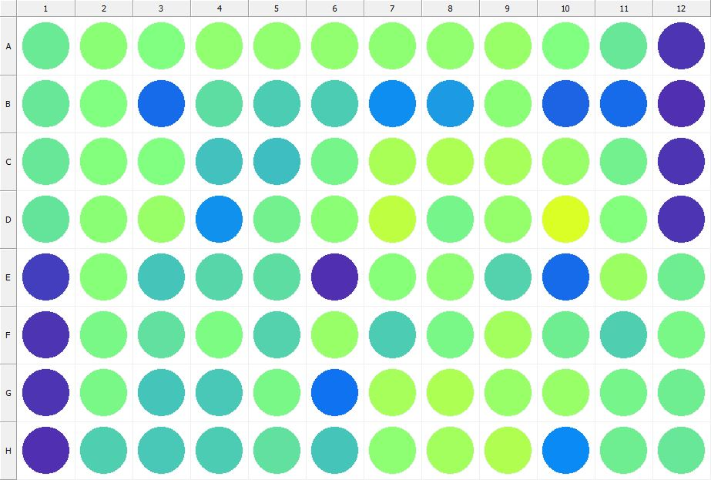

|  |
| --- |
| **Results for Tim_CTB(1) - channel 1 (RFU)** |

|  |  |  |  |  |  |  |  |  |  |  |  |  |
| --- | --- | --- | --- | --- | --- | --- | --- | --- | --- | --- | --- | --- |
|  | 01 | 02 | 03 | 04 | 05 | 06 | 07 | 08 | 09 | 10 | 11 | 12 |
| A | 156696 | 177907 | 172766 | 183730 | 183619 | 183041 | 179862 | 183859 | 186863 | 170897 | 154788 | 34105 |
| B | 156466 | 171575 | 73021 | 147859 | 136592 | 137786 | 95090 | 104223 | 179380 | 67502 | 72479 | 33484 |
| C | 156219 | 174611 | 171375 | 129359 | 127589 | 165353 | 198337 | 202034 | 196186 | 186819 | 163391 | 34919 |
| D | 153880 | 178775 | 187131 | 97067 | 162889 | 179559 | 212559 | 164564 | 186551 | 231070 | 173902 | 35366 |
| E | 40768 | 175211 | 133265 | 144885 | 149141 | 31692 | 175582 | 180179 | 142077 | 72191 | 191193 | 160264 |
| F | 35419 | 166750 | 151851 | 168451 | 141301 | 186965 | 136839 | 166897 | 194413 | 159443 | 139435 | 165931 |
| G | 35517 | 168100 | 131678 | 134667 | 168034 | 75706 | 197502 | 202705 | 186875 | 188384 | 165648 | 160534 |
| H | 33509 | 139083 | 135033 | 136409 | 149969 | 131649 | 181626 | 193795 | 204435 | 93288 | 161119 | 156391 |

|  |  |
| --- | --- |
| **Plate information** | |
|  | |
| **Plate** | 8 |
| **Repeat** | 1 |
| **Barcode** |  |
| **Measured height** | 14.78 |
| **Inside temperature at start** | 23.64 |
| **Inside temperature at end** | 23.73 |
| **Humidity at start** | 15.7 |
| **Humidity at end** | 15.5 |
| **Ambient temperature at start** | 23.54 |
| **Ambient temperature at end** | 23.54 |
| **Group** | 1 |
| **Label** | Tim_CTB(1) |
| **ScanX** | 0 |
| **ScanY** | 0 |
| **Measinfo** | De=1st Ex=Top Em=Top Wdw=N/A (14) |
| **Kinetics** | 0 |
| **Measurement date** | 11/21/2022 2:50:31 PM |
|  | |

|  |
| --- |
| **Background information** |
| Legend:  HDR1 - Plate  HDR2 - Label  HDR3 - Result  HDR4 - Signal  HDR5 - Flashes/Time  HDR6 - Meastime  HDR7 - MeasInfo |
| HDR1 HDR2 HDR3 HDR4 HDR5 HDR6 HDR7  8 Tim_CTB 0 1145 1 00:00:00.000 De=1st Ex=Top Em=Top Wdw=N/A (14) |
|  |

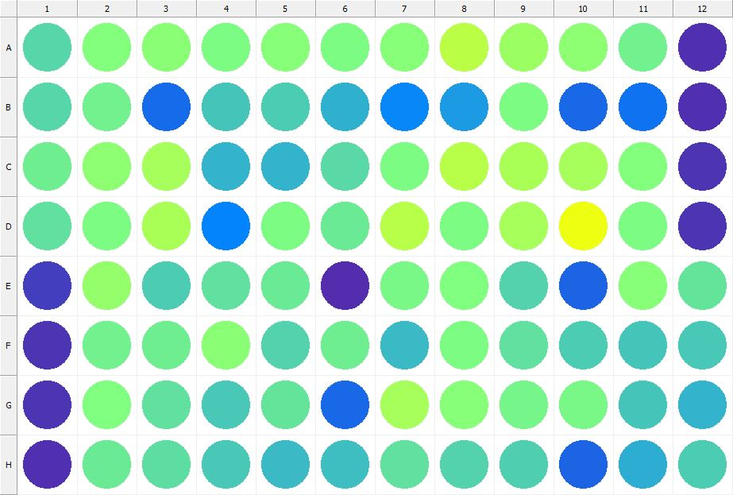

|  |
| --- |
| **Results for Tim_CTB(1) - channel 1 (RFU)** |

|  |  |  |  |  |  |  |  |  |  |  |  |  |
| --- | --- | --- | --- | --- | --- | --- | --- | --- | --- | --- | --- | --- |
|  | 01 | 02 | 03 | 04 | 05 | 06 | 07 | 08 | 09 | 10 | 11 | 12 |
| A | 143221 | 174777 | 178749 | 170063 | 176532 | 170331 | 176984 | 210905 | 191226 | 180169 | 162542 | 33626 |
| B | 144097 | 163092 | 72561 | 131718 | 137586 | 117449 | 90654 | 104906 | 170109 | 68651 | 76475 | 33052 |
| C | 159942 | 181211 | 198313 | 120571 | 120485 | 146869 | 169107 | 209874 | 199872 | 197619 | 173818 | 34208 |
| D | 151073 | 169200 | 199672 | 88999 | 169850 | 158659 | 208642 | 168475 | 196719 | 245527 | 168474 | 34674 |
| E | 40836 | 186108 | 135910 | 151583 | 156711 | 30740 | 167598 | 172089 | 141755 | 66408 | 177132 | 152918 |
| F | 35820 | 162776 | 159713 | 178257 | 141420 | 161046 | 126354 | 168507 | 150610 | 137351 | 132487 | 133417 |
| G | 35089 | 171576 | 151649 | 133834 | 153217 | 69015 | 197767 | 175800 | 163756 | 166053 | 131383 | 121524 |
| H | 32986 | 156580 | 148281 | 134015 | 125743 | 126562 | 151472 | 142489 | 140017 | 67968 | 115160 | 135772 |

|  |  |
| --- | --- |
| **Plate information** | |
|  | |
| **Plate** | 9 |
| **Repeat** | 1 |
| **Barcode** |  |
| **Measured height** | 14.78 |
| **Inside temperature at start** | 23.73 |
| **Inside temperature at end** | 23.75 |
| **Humidity at start** | 15.5 |
| **Humidity at end** | 15.4 |
| **Ambient temperature at start** | 23.44 |
| **Ambient temperature at end** | 23.56 |
| **Group** | 1 |
| **Label** | Tim_CTB(1) |
| **ScanX** | 0 |
| **ScanY** | 0 |
| **Measinfo** | De=1st Ex=Top Em=Top Wdw=N/A (14) |
| **Kinetics** | 0 |
| **Measurement date** | 11/21/2022 2:52:02 PM |
|  | |

|  |
| --- |
| **Background information** |
| Legend:  HDR1 - Plate  HDR2 - Label  HDR3 - Result  HDR4 - Signal  HDR5 - Flashes/Time  HDR6 - Meastime  HDR7 - MeasInfo |
| HDR1 HDR2 HDR3 HDR4 HDR5 HDR6 HDR7  9 Tim_CTB 0 1126 1 00:00:00.000 De=1st Ex=Top Em=Top Wdw=N/A (14) |
|  |

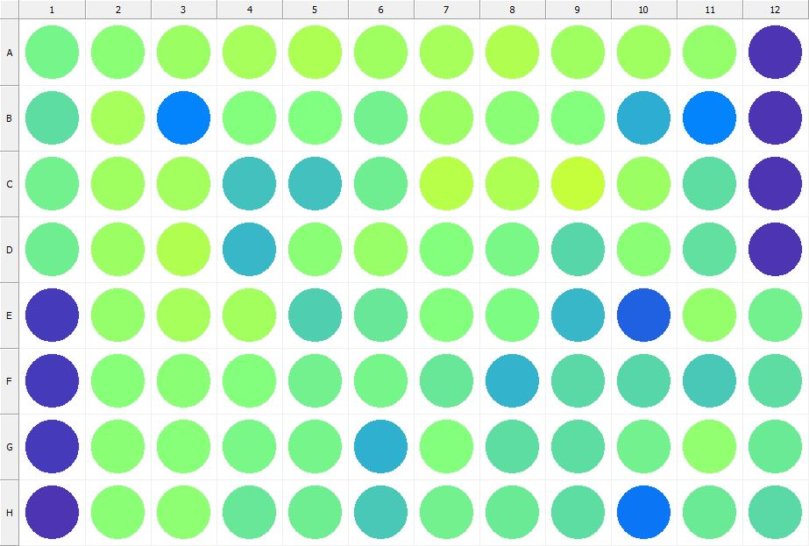

|  |
| --- |
| **Results for Tim_CTB(1) - channel 1 (RFU)** |

|  |  |  |  |  |  |  |  |  |  |  |  |  |
| --- | --- | --- | --- | --- | --- | --- | --- | --- | --- | --- | --- | --- |
|  | 01 | 02 | 03 | 04 | 05 | 06 | 07 | 08 | 09 | 10 | 11 | 12 |
| A | 165000 | 177814 | 190912 | 196045 | 202069 | 191769 | 197433 | 203672 | 192562 | 192601 | 185159 | 34262 |
| B | 149332 | 197107 | 88603 | 175122 | 172497 | 161924 | 190323 | 179709 | 174364 | 116556 | 87678 | 33872 |
| C | 163100 | 192497 | 194494 | 129025 | 130323 | 159678 | 209101 | 201467 | 216948 | 189435 | 148072 | 34045 |
| D | 159374 | 190237 | 204954 | 122825 | 179107 | 186766 | 174836 | 166607 | 144649 | 177760 | 151404 | 34971 |
| E | 39238 | 186342 | 197636 | 195333 | 139238 | 154986 | 173218 | 168499 | 123552 | 64078 | 186016 | 162033 |
| F | 40297 | 176937 | 178228 | 174987 | 161517 | 164599 | 154283 | 119893 | 145300 | 144252 | 134949 | 149053 |
| G | 38473 | 179752 | 175528 | 166796 | 164883 | 117842 | 174348 | 149591 | 147512 | 162240 | 182758 | 157218 |
| H | 33837 | 178303 | 180176 | 154896 | 161130 | 134133 | 162915 | 157083 | 149063 | 78883 | 157523 | 146650 |

|  |  |
| --- | --- |
| **Plate information** | |
|  | |
| **Plate** | 10 |
| **Repeat** | 1 |
| **Barcode** |  |
| **Measured height** | 14.78 |
| **Inside temperature at start** | 23.73 |
| **Inside temperature at end** | 23.73 |
| **Humidity at start** | 15.2 |
| **Humidity at end** | 15.4 |
| **Ambient temperature at start** | 23.34 |
| **Ambient temperature at end** | 23.44 |
| **Group** | 1 |
| **Label** | Tim_CTB(1) |
| **ScanX** | 0 |
| **ScanY** | 0 |
| **Measinfo** | De=1st Ex=Top Em=Top Wdw=N/A (14) |
| **Kinetics** | 0 |
| **Measurement date** | 11/21/2022 2:52:49 PM |
|  | |

|  |
| --- |
| **Background information** |
| Legend:  HDR1 - Plate  HDR2 - Label  HDR3 - Result  HDR4 - Signal  HDR5 - Flashes/Time  HDR6 - Meastime  HDR7 - MeasInfo |
| HDR1 HDR2 HDR3 HDR4 HDR5 HDR6 HDR7  10 Tim_CTB 0 1069 1 00:00:00.000 De=1st Ex=Top Em=Top Wdw=N/A (14) |
|  |

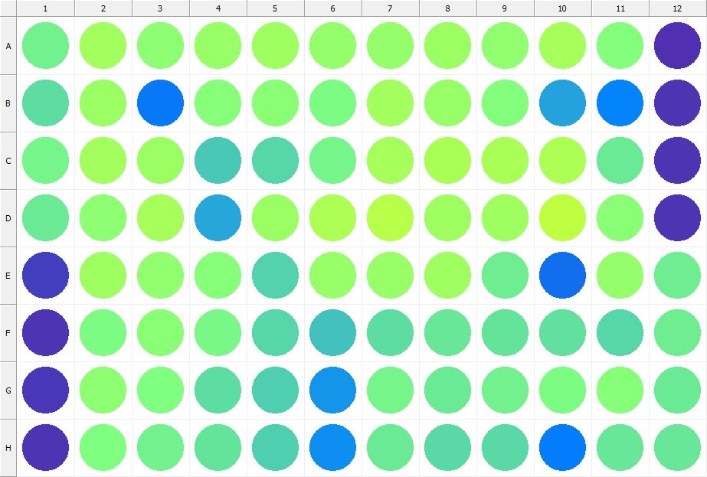

|  |
| --- |
| **Results for Tim_CTB(1) - channel 1 (RFU)** |

|  |  |  |  |  |  |  |  |  |  |  |  |  |
| --- | --- | --- | --- | --- | --- | --- | --- | --- | --- | --- | --- | --- |
|  | 01 | 02 | 03 | 04 | 05 | 06 | 07 | 08 | 09 | 10 | 11 | 12 |
| A | 161379 | 195164 | 179981 | 188031 | 193609 | 184747 | 185047 | 190342 | 182321 | 196465 | 174343 | 33341 |
| B | 149172 | 190944 | 81059 | 176856 | 177641 | 169792 | 195631 | 187685 | 174693 | 108564 | 87194 | 33790 |
| C | 165226 | 194195 | 190417 | 134724 | 144726 | 163748 | 198108 | 199803 | 199677 | 201543 | 158099 | 34378 |
| D | 158861 | 181264 | 196194 | 111567 | 189317 | 202661 | 207960 | 193523 | 192260 | 213048 | 178944 | 35043 |
| E | 40823 | 192165 | 183394 | 176667 | 140376 | 187284 | 187764 | 192082 | 160890 | 74538 | 186317 | 160659 |
| F | 35231 | 168793 | 178156 | 166329 | 142702 | 129232 | 148642 | 155793 | 153575 | 150440 | 143812 | 159683 |
| G | 38028 | 180130 | 172099 | 147667 | 138792 | 100605 | 164049 | 156849 | 163088 | 170329 | 176761 | 158425 |
| H | 34188 | 172390 | 162538 | 153285 | 139209 | 95708 | 157806 | 146826 | 147120 | 83920 | 155336 | 155444 |

|  |  |
| --- | --- |
| **Plate information** | |
|  | |
| **Plate** | 11 |
| **Repeat** | 1 |
| **Barcode** |  |
| **Measured height** | 14.78 |
| **Inside temperature at start** | 23.73 |
| **Inside temperature at end** | 23.73 |
| **Humidity at start** | 15.4 |
| **Humidity at end** | 15.4 |
| **Ambient temperature at start** | 23.44 |
| **Ambient temperature at end** | 23.44 |
| **Group** | 1 |
| **Label** | Tim_CTB(1) |
| **ScanX** | 0 |
| **ScanY** | 0 |
| **Measinfo** | De=1st Ex=Top Em=Top Wdw=N/A (14) |
| **Kinetics** | 0 |
| **Measurement date** | 11/21/2022 2:53:34 PM |
|  | |

|  |
| --- |
| **Background information** |
| Legend:  HDR1 - Plate  HDR2 - Label  HDR3 - Result  HDR4 - Signal  HDR5 - Flashes/Time  HDR6 - Meastime  HDR7 - MeasInfo |
| HDR1 HDR2 HDR3 HDR4 HDR5 HDR6 HDR7  11 Tim_CTB 0 1088 1 00:00:00.000 De=1st Ex=Top Em=Top Wdw=N/A (14) |
|  |

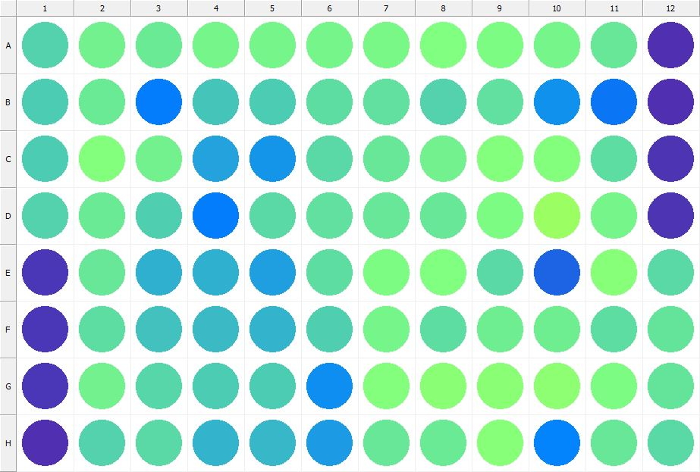

|  |
| --- |
| **Results for Tim_CTB(1) - channel 1 (RFU)** |

|  |  |  |  |  |  |  |  |  |  |  |  |  |
| --- | --- | --- | --- | --- | --- | --- | --- | --- | --- | --- | --- | --- |
|  | 01 | 02 | 03 | 04 | 05 | 06 | 07 | 08 | 09 | 10 | 11 | 12 |
| A | 142361 | 162913 | 157875 | 163604 | 164516 | 165699 | 167308 | 171565 | 169369 | 165621 | 155594 | 32771 |
| B | 136877 | 156586 | 82351 | 133008 | 137202 | 148806 | 150292 | 141665 | 150542 | 98058 | 78058 | 32894 |
| C | 135936 | 174067 | 161274 | 109658 | 99517 | 145495 | 155667 | 161256 | 174813 | 173203 | 149137 | 34454 |
| D | 140567 | 158662 | 140179 | 82900 | 145000 | 149778 | 155148 | 155851 | 168211 | 190595 | 165751 | 34687 |
| E | 38140 | 155365 | 119297 | 118728 | 107679 | 149184 | 168831 | 170669 | 146951 | 66181 | 176300 | 145774 |
| F | 36407 | 147893 | 129582 | 124507 | 121299 | 138673 | 164006 | 147825 | 160200 | 161081 | 149120 | 152913 |
| G | 36631 | 161662 | 143383 | 135965 | 135735 | 94511 | 173884 | 178997 | 178492 | 181988 | 169686 | 153241 |
| H | 32841 | 141838 | 147180 | 120349 | 123162 | 104240 | 154612 | 157887 | 176071 | 87476 | 155977 | 146001 |

|  |  |
| --- | --- |
| **Plate information** | |
|  | |
| **Plate** | 12 |
| **Repeat** | 1 |
| **Barcode** |  |
| **Measured height** | 14.78 |
| **Inside temperature at start** | 23.73 |
| **Inside temperature at end** | 23.73 |
| **Humidity at start** | 15.4 |
| **Humidity at end** | 15.4 |
| **Ambient temperature at start** | 23.34 |
| **Ambient temperature at end** | 23.44 |
| **Group** | 1 |
| **Label** | Tim_CTB(1) |
| **ScanX** | 0 |
| **ScanY** | 0 |
| **Measinfo** | De=1st Ex=Top Em=Top Wdw=N/A (14) |
| **Kinetics** | 0 |
| **Measurement date** | 11/21/2022 2:54:19 PM |
|  | |

|  |
| --- |
| **Background information** |
| Legend:  HDR1 - Plate  HDR2 - Label  HDR3 - Result  HDR4 - Signal  HDR5 - Flashes/Time  HDR6 - Meastime  HDR7 - MeasInfo |
| HDR1 HDR2 HDR3 HDR4 HDR5 HDR6 HDR7  12 Tim_CTB 0 1031 1 00:00:00.000 De=1st Ex=Top Em=Top Wdw=N/A (14) |
|  |

|  |  |
| --- | --- |
|  | |
| **Basic assay information** | |
| **Assay ID** | 24221 |
| **Assay Started** | 11/21/2022 2:45:03 PM |
| **Assay Finished** | 11/21/2022 2:54:37 PM |
| **Assay Exported** | 11/21/2022 3:16:48 PM |
| **Protocol ID** | 100568 |
| **Protocol Name** | Copy of 96well-CTB_Tim |
| **Serial#** | 1020141 |
|  | |
|  | |
|  | |
| **Protocol information** | |
| **Protocol:** | |
| **Protocol name** | Copy of 96well-CTB_Tim |
| **Number of assay repeats** | 1 |
| **Start assay repeat each** | N/A |
| **Number of plate repeats** | 1 |
| **Start plate repeat each** | N/A |
| **Is label meas. height used** | Yes |
| **Height of measurement** | Defined in label |
| **Is gripper height used** | No |
| **Mode of measurement** | By Rows, bi-directional |
| **Rotated plate** | No |
| **Soft move** | No |
| **Protocol notes** |  |
|  | |
| **Plate type:** | |
| **Name of the plate type** | 96 General |
| **Number of rows** | 8 |
| **Number of columns** | 12 |
| **Number of the wells in the plate** | 96 |
| **Height of the plate** | 14.35 mm |
|  | |
| **Coordinates of corners:** | |
| **96 General + Tim_CTB** | |
| 14.38 mm x------------------------------------------------------ x 113.38 mm  11.24 mm 11.24 mm | |
| 14.38 mm x------------------------------------------------------ x 113.38 mm  74.24 mm 74.24 mm | |
|  | |
|  | |

|  |  |
| --- | --- |
| **Platemap:** | |
| **Plate** | 1 |
| **Group** | 1 |
|  | |

|  |  |  |  |  |  |  |  |  |  |  |  |  |
| --- | --- | --- | --- | --- | --- | --- | --- | --- | --- | --- | --- | --- |
|  | **01** | **02** | **03** | **04** | **05** | **06** | **07** | **08** | **09** | **10** | **11** | **12** |
| **A** | - | - | - | - | - | - | - | - | - | - | - | - |
| **B** | - | - | - | - | - | - | - | - | - | - | - | - |
| **C** | - | - | - | - | - | - | - | - | - | - | - | - |
| **D** | - | - | - | - | - | - | - | - | - | - | - | - |
| **E** | - | - | - | - | - | - | - | - | - | - | - | - |
| **F** | - | - | - | - | - | - | - | - | - | - | - | - |
| **G** | - | - | - | - | - | - | - | - | - | - | - | - |
| **H** | - | - | - | - | - | - | - | - | - | - | - | - |

|  |  |
| --- | --- |
|  | |
| **-** | Undefined |
|  | |
|  | |

|  |  |
| --- | --- |
| **Calculations:** | |
| **No calculations.** | |
|  | |
| **Auto export parameters:** | |
| **Export format** | Plate2 |
| **Include basic assay information** | Yes |
| **Place assay information at** | End of file |
| **Include basic plate information** | Yes |
| **Place plate information at** | Beginning of plate |
| **Include protocol information** | Yes |
| **Protocol info level** | Large |
| **Include error and warning information** | Yes |
| **Include background information** | Yes |
| **Add plate number to the file name** | Yes |
| **Each plate to separate file** | No |
| **Field separator to use** | System |
| **File name format** | <DefaultDataFolder>\<Date>\<ProtocolName>_<AssayID>.csv |
|  | |
| **Operations:** | |
| Plate 1  Group 1  Measurement  Label..................................................... Tim_CTB(1) | |
| **Labels:** | |
| **Tim_CTB** | 4000137 |
| **Top mirror** | General |
| **Bottom mirror** | N/A |
| **Exc. filter** | Photometric 530 |
| **Using of excitation filter** | Top |
| **2nd exc. filter** | N/A |
| **Using of 2nd excitation filter** | Top |
| **Ems. filter** | Photometric 590 |
| **2nd ems. filter** | N/A |
| **Measurement height** | 6.5 mm |
| **Number of flashes** | 1 |
| **Number of flashes integrated** | 1 |
| **PMT gain** | 1 |
| **Excitation light** | 100% |
| **Reference excitation light** | 100% |
| **Emission light** | 100% |
| **Reference AD gain** | 4 |
| **Reference signal** | 383728 |
| **Last edited** | 2/11/2019 10:20:00 AM |
| **Last edited by** | EnVision |
| **Factory preset** | No |
|  | |
| **Filters:** | |
| **Photometric 530** | 310 |
| **Filter type** | Excitation |
| **Description** | P530 CWL=530nm BW=8nm Tmin=55% |
| **Used with** | Absorbance,DELFIA - Time-resolved Fluorescence,Fluorescence Intensity,Fluorescence Polarization,LANCE - Time-resolved Fluorescence |
| **Last edited** | 8/19/2014 4:24:21 PM |
| **Last edited by** | Installation |
| **Factory preset** | Yes |
|  | |
| **Photometric 590** | 314 |
| **Filter type** | Excitation |
| **Description** | P590 CWL=590nm BW=8nm Tmin=40% |
| **Used with** | Absorbance,DELFIA - Time-resolved Fluorescence,Fluorescence Intensity,Fluorescence Polarization,LANCE - Time-resolved FluorescenceAbsorbance,DELFIA - Time-resolved Fluorescence,Fluorescence Intensity,Fluorescence Polarization,LANCE - Time-resolved Fluorescence |
| **Last edited** | 8/19/2014 4:24:21 PM |
| **Last edited by** | Installation |
| **Factory preset** | Yes |
|  | |
| **Mirror modules:** | |
| **General** | 401 |
| **Used by** | Top |
| **Dual** | No |
| **Bias** | No |
| **Description** | BS50 |
| **Used with** | Luminescence,DELFIA - Time-resolved Fluorescence,Fluorescence Intensity,Fluorescence Polarization,LANCE - Time-resolved Fluorescence |
| **Last edited** | 8/19/2014 4:24:21 PM |
| **Last edited by** | Installation |
| **Factory preset** | Yes |
|  | |
| **Instrument:** | |
| **Serial number** | 1020141 |
| **Nickname** | EnVision |
|  | |
|  | |
|  | |
|  | |
| **Notifications:** | |
| Assay notifications:  INFO: Assay aborted at plate 12 plate repeat 1 and well H01. There may be missing results | |
|  | |
|  | |

|  |
| --- |
|  |
| **Exported with EnVision Workstation version 1.13.3009.1409** |